






Use English at a supervisory level
D2.LAN.CL10.02
Trainee Manual

Use English at a supervisory level
D2.LAN.CL10.02
Trainee Manual





Project Base
William Angliss Institute of TAFE
555 La Trobe Street
Melbourne 3000 Victoria
Telephone: | (03) 9606 2111
Facsimile: | (03) 9670 1330
Acknowledgements
Project Director: | Wayne Crosbie
Project Manager | Jim Irwin
Chief Writer: | Alan Hickman
Subject Writer: | Quentin Derrick
Editor: | Jim Irwin
DTP/Production: | Daniel Chee, Mai Vu, Cindy Curran

The Association of Southeast Asian Nations (ASEAN) was established on 8 August 1967. The Member States of the Association are Brunei Darussalam, Cambodia, Indonesia, Lao PDR, Malaysia, Myanmar, Philippines, Singapore, Thailand and Viet Nam.
The ASEAN Secretariat is based in Jakarta, Indonesia.
General Information on ASEAN appears online at the ASEAN Website: www.asean.org.
All text is produced by William Angliss Institute of TAFE for the ASEAN Project on “Toolbox Development for Tourism Labour Divisions for Travel Agencies and Tour Operations”.
This publication is supported by the Australian Government’s aid program through the ASEAN-Australia Development Cooperation Program Phase II (AADCP II).
Copyright: Association of Southeast Asian Nations (ASEAN) 2015.
All rights reserved.
Disclaimer
Every effort has been made to ensure that this publication is free from errors or omissions. However, you should conduct your own enquiries and seek professional advice before relying on any fact, statement or matter contained in this book. The ASEAN Secretariat and William Angliss Institute of TAFE are not responsible for any injury, loss or damage as a result of material included or omitted from this course. Information in this module is current at the time of publication. Time of publication is indicated in the date stamp at the bottom of each page.
Some images appearing in this resource have been purchased from stock photography suppliers Shutterstock and iStockphoto and other third party copyright owners and as such are non-transferable and non-exclusive. Clip arts, font images and illustrations used are from the Microsoft Office Clip Art and Media Library. Some images have been provided by and are the property of William Angliss Institute.
Additional images have been sourced from Flickr and SXC and are used under Creative Commons licence: http://creativecommons.org/licenses/by/2.0/deed.en

File name: TM_Use_English_at_a_supervisory_level_240715





Table of contents
Introduction to trainee manual 1
Unit descriptor 3
Assessment matrix 5
Glossary 7
Element 1: Use English to induct new employees 9
Element 2: Conduct a staff meeting 31
Element 3: Supervise and motivate a work team 45
Presentation of written work 55
Recommended reading 57
Trainee evaluation sheet 59
Trainee self-assessment checklist 61

Introduction to trainee manual

To the Trainee
Congratulations on joining this course. This Trainee Manual is one part of a ‘toolbox’ which is a resource provided to trainees, trainers and assessors to help you become competent in various areas of your work.
The ‘toolbox’ consists of three elements:
- A Trainee Manual for you to read and study at home or in class
- A Trainer Guide with Power Point slides to help your Trainer explain the content of the training material and provide class activities to help with practice
- An Assessment Manual which provides your Assessor with oral and written questions and other assessment tasks to establish whether or not you have achieved competency.
The first thing you may notice is that this training program and the information you find in the Trainee Manual seems different to the textbooks you have used previously. This is because the method of instruction and examination is different. The method used is called Competency based training (CBT) and Competency based assessment (CBA). CBT and CBA is the training and assessment system chosen by ASEAN (Association of South-East Asian Nations) to train people to work in the tourism and hospitality industry throughout all the ASEAN member states.
What is the CBT and CBA system and why has it been adopted by ASEAN?
CBT is a way of training that concentrates on what a worker can do or is required to do at work. The aim is of the training is to enable trainees to perform tasks and duties at a standard expected by employers. CBT seeks to develop the skills, knowledge and attitudes (or recognise the ones the trainee already possesses) to achieve the required competency standard. ASEAN has adopted the CBT/CBA training system as it is able to produce the type of worker that industry is looking for and this therefore increases trainees chances of obtaining employment.
CBA involves collecting evidence and making a judgement of the extent to which a worker can perform his/her duties at the required competency standard. Where a trainee can already demonstrate a degree of competency, either due to prior training or work experience, a process of ‘Recognition of Prior Learning’ (RPL) is available to trainees to recognise this. Please speak to your trainer about RPL if you think this applies to you.
What is a competency standard?
Competency standards are descriptions of the skills and knowledge required to perform a task or activity at the level of a required standard.
242 competency standards for the tourism and hospitality industries throughout the ASEAN region have been developed to cover all the knowledge, skills and attitudes required to work in the following occupational areas:
- Housekeeping
- Food Production
- Food and Beverage Service
- Front Office
- Travel Agencies
- Tour Operations.
All of these competency standards are available for you to look at. In fact you will find a summary of each one at the beginning of each Trainee Manual under the heading ‘Unit Descriptor’. The unit descriptor describes the content of the unit you will be studying in the Trainee Manual and provides a table of contents which are divided up into ‘Elements’ and ‘Performance Criteria”. An element is a description of one aspect of what has to be achieved in the workplace. The ‘Performance Criteria’ below each element details the level of performance that needs to be demonstrated to be declared competent.
There are other components of the competency standard:
- Unit Title: statement about what is to be done in the workplace
- Unit Number: unique number identifying the particular competency
- Nominal hours: number of classroom or practical hours usually needed to complete the competency. We call them ‘nominal’ hours because they can vary e.g. sometimes it will take an individual less time to complete a unit of competency because he/she has prior knowledge or work experience in that area.
The final heading you will see before you start reading the Trainee Manual is the ‘Assessment Matrix’. Competency based assessment requires trainees to be assessed in at least 2 – 3 different ways, one of which must be practical. This section outlines three ways assessment can be carried out and includes work projects, written questions and oral questions. The matrix is designed to show you which performance criteria will be assessed and how they will be assessed. Your trainer and/or assessor may also use other assessment methods including ‘Observation Checklist’ and ‘Third Party Statement’. An observation checklist is a way of recording how you perform at work and a third party statement is a statement by a supervisor or employer about the degree of competence they believe you have achieved. This can be based on observing your workplace performance, inspecting your work or gaining feedback from fellow workers.
Your trainer and/or assessor may use other methods to assess you such as:
- Journals
- Oral presentations
- Role plays
- Log books
- Group projects
- Practical demonstrations.
Remember your trainer is there to help you succeed and become competent. Please feel free to ask him or her for more explanation of what you have just read and of what is expected from you and best wishes for your future studies and future career in tourism and hospitality.

Unit descriptor
Use English at a supervisory level
This unit deals with the skills and knowledge required to Use English at a supervisory level in a range of settings within the travel industries workplace context.
Unit Code:
D2.LAN.CL10.02
Nominal Hours:
120

Element 1: Use English to induct new employees
Performance Criteria
1.1 Welcome new employee(s) and introduce them to key personnel
1.2 Explain how the position relates to others in the company
1.3 Speak positively about the company structure, goals and priorities
1.4 Give information about the new employee’s roles and responsibilities
1.5 Show and explain features in the work area
1.6 Outline details of any training requirements

Element 2: Conduct a staff meeting
Performance Criteria
2.1 Notify all relevant staff of scheduled staff meeting
2.2 Draw up an agenda for the staff meeting
2.3 Chair the meeting
2.4 Develop an action plan and dates

Element 3: Supervise and motivate a work team
Performance Criteria
3.1 Give clear instructions of work to be completed and realistic deadlines
3.2 Check instructions have been understood by all involved
3.3 Give constructive feedback on performance
3.4 Seek suggestions for improvements from staff

Assessment matrix
Showing mapping of Performance Criteria against Work Projects, Written Questions and Oral Questions
The Assessment Matrix indicates three of the most common assessment activities your Assessor may use to assess your understanding of the content of this manual and your performance - Work Projects, Written Questions and Oral Questions. It also indicates where you can find the subject content related to these assessment activities in the Trainee Manual (i.e. under which element or performance criteria). As explained in the Introduction, however, the assessors are free to choose which assessment activities are most suitable to best capture evidence of competency as they deem appropriate for individual students.
 |  |  | Work Projects | Written Questions | Oral Questions
Element 1: Use English to induct new employees
1.1 | Welcome new employee(s) and introduce them to key personnel |  | 1.1 | 1,2,3 | 1,2
1.2 | Explain how the position relates to others in the company |  | 1.2 | 4,5,6 | 3,4
1.3 | Speak positively about the company structure, goals and priorities |  | 1.3 | 7,8,9 | 5,6
1.4 | Give information about the new employee’s roles and responsibilities |  | 1.4 | 10,11,12 | 7,8
1.5 | Show and explain features in the work area |  | 1.5 | 13,14,15 | 9,10
1.6 | Outline details of any training requirements |  | 1.6 | 16,17,18 | 11,12
Element 2: Conduct a staff meeting
2.1 |  | Notify all relevant staff of scheduled staff meeting | 2.1 | 19, 20, 21 | 13, 14
2.2 |  | Draw up an agenda for the staff meeting | 2.2 | 22, 23, 24 | 15, 16
2.3 |  | Chair the meeting | 2.3 | 25,26,27 | 17, 18
2.4 |  | Develop an action plan and dates | 2.4 | 28, 29, 30 | 19, 20
Element 3: Supervise and motivate a work team
3.1 | Give clear instructions of work to be completed and realistic deadlines |  | 3.1 | 31, 32, 33 | 21, 22
3.2 | Check instructions have been understood by all involved |  | 3.2 | 34, 35, 36 | 23, 24
3.3 | Give constructive feedback on performance |  | 3.3 | 37, 38, 39 | 25, 26
3.4 | Seek suggestions for improvements from staff |  | 3.4 | 40, 41, 42 | 27, 28

Glossary
Term | Explanation
action plan | outline of steps to be taken to complete a set of tasks or to achieve a specific goal
agenda | a list of items to be discussed at a formal meeting
chair (a meeting) | the person in charge of a meeting
employee | a person employed for wages or salary
feature | a distinctive attribute or aspect of something
feedback | information about reactions to a product, a person's performance of a task, etc., used as a basis for improvement
function | an activity or purpose natural to or intended for a person or thing
goals | the object of a person's ambition or effort; an aim or desired result
induct | admit (someone) formally to a position or organisation
mentor | an experienced and trusted adviser
mission statement | a formal summary of the aims and values of a company, organisation, or individual
orientation (job) | to introduce a new person to an organisation
personnel | people working within an organisation
priorities | things considered to be the most important to attend to
relationship | the way in which two or more concepts, objects, or people are connected, or the state of being connected
response | a reaction to something
responsibility | the state or fact of having a duty to deal with something or of having control over someone
role | the function assumed or part played by a person or thing in a particular situation
suggestion | an idea or plan put forward for consideration
supervisor | a person who supervises a person or an activity

Element 1:
Use English to induct new employees

1.1 Welcome new employee(s) and introduce them to key personnel


Introduction
An organization only has one chance to make a good first impression with the new hire, and the first few days will leave a lasting impression. Making new employees feel welcome will result in high employee loyalty and retention and will be reflected in the success of the organisation. It is important then to make sure that all new employees are provided with an opportunity to meet the people they will work most closely with.

Planning for new employees
Like many things in life, preparation is the key to success. When working in a foreign language, preparation becomes even more important. There are many processes and materials that can be arranged in anticipation of new staff joining the organisation. It is important to ensure that all new staff receive the same level of attention when they join the company.

HAVE A WELCOME STRATEGY IN PLACE
From management down, everyone directly involved with a new hire has a role in making the new person feel welcome. Everyone should be asked, "What was it like for you on your first day and week?" and "What could others have done to make you feel more comfortable, accepted, and appreciated?" Use these questions to brainstorm and come up with a detailed plan for bringing a new person into your organization.
Once the plan is developed and in writing, have everyone involved implement the plan whenever a new employee arrives. Having a written plan reminds staff of the importance of first impressions and doing a good job of welcoming staff. Doing this also points out that everyone has an important role to play.

HAVE A PERSONAL COLLAGE OF ALL IMMEDIATE STAFF
One of the concerns that creates anxiety for a new employee is wondering how they will fit in. On the first day they will likely meet a lot of new people and have trouble remembering their names.
Instead of handing them a sterile organizational chart with names and titles, how about a collage with photos and personal information of the staff the person will be working with. This could include photos of supervisors, co-workers, and some information on their personal lives such as family, pets, hobbies, favourite travel destinations, or favourite sayings—whatever the employee felt comfortable sharing.
Having this information at his disposal would take the pressure off the new person to remember the many faces that he met the first day. This would also put a human face on the organisation and make a newcomer feel more comfortable.

HAVE A MENTOR OR BUDDY SYSTEM
Whenever a new person is brought on board, assign someone to spend time with them to show them how things work, go for lunch together, and offer support and guidance when needed. This could be undertaken by one person or rotated amongst volunteer staff.
While the mentor or buddy would have the main role, other employees should also be encouraged to jump in and do their part to do small things to make the newcomer feel welcome.

4. EXPRESS A GENUINE INTEREST IN THE NEW EMPLOYEE AS A PERSON
Knowing whether a person is auditory, kinaesthetic, or visual will tell us how he prefers to be appreciated. For an auditory person, being given a verbal compliment is better than a hand written note, whereas the visual person will prefer the note. A kinaesthetic person will appreciate handshakes and solid eye contact.
While it is not always possible to have this information about new people at work, it is very helpful to find out. If we don’t know or are unsure, do all three to ensure there will be one way the person will truly appreciate. The more we know about a new employee the more we are able to personalize the welcome and heighten their experience so the gesture is appreciated and remembered.

5. IMMERSE A NEW HIRE IN THE COMPANY CULTURE AS SOON AS POSSIBLE
Immersing a new employee into the organizational culture quickly is the best way to make them feel like a valuable part of the team. Assign them roles and ask for his input in all the areas they are involved. Encourage him to come up with his own personal plan for what he wants to do or accomplish in the future. Make a point of involving him in all of the social and fun activities around the workplace. When in meetings make a point of asking for his input and actively listen to what he has to say.


Introducing someone
There are many ways to introduce yourself and others in English. When using this language it should seem natural and easy to use.

Introducing yourself:
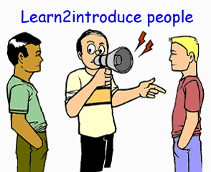
Here are expressions to introduce yourself:
- My name is ...
- I’m....
- Nice to meet you; I'm ...
- Pleased to meet you; I'm ...
- Let me introduce myself; I'm ...
- I'd like to introduce myself; I'm ...

Introducing others:
Here are expressions to introduce others:
- Jack, please meet Nicolas.
- Jack, have you met Nicolas?
- I'd like you to meet Liza.
- I'd like to introduce you to Betty.
- Leila, this is Barbara. Barbara this is Leila.

Useful responses when introducing yourself or other people:
- Nice to meet you.
- Pleased to meet you.
- Happy to meet you.
- How do you do?

Dialogue:
Alex is talking to the new manager and his assistant. Notice how they introduce themselves:
Alex: | Hi! My name is Alex Litterman, the new manager.
William: | Hi! I'm William O'Brian. Nice to meet you, Mr Alex Litterman.
John: | William, please meet Mr Steve Lynch, my assistant
Jack: | How do you do?
Nicolas: | How do you do?

Things to remember:
- When introducing yourself or other people in a formal situation use full names. ("I'm Alex Litterman.")
- "How do you do?" isn't really a question, it just means "Hello"

Key personnel in the organisation
Look at the organisation chart below and identify the important people related to your job.
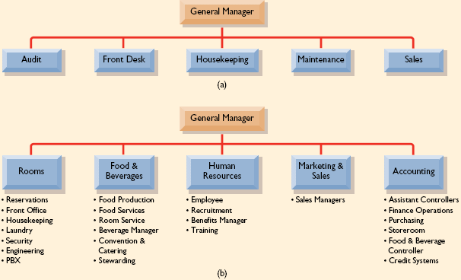


1.2 Explain how the position relates to others in the company

Introduction
It is important to understand how a position relates to other positions within an organisation in order to better achieve the overall goals of the company. Being unaware of how a certain job roles impacts on others, can cause stress and ineffective performance across the organisation as a whole.

Role clarity and relationship to other positions
A wide range of work situations can create role confusion, such as beginning a new job, starting in a new organisation, a transfer, a new supervisor or manager or following a change in the structure of a work unit. Lack of role clarity can lead to tension and conflict between workers.
In any large business as large, there are many different jobs. Organisational structure is complex, so to help individuals within the business understand their roles and responsibilities, many organisations have a set of Business Principles that demonstrate their commitment to operating ethically and responsibly. This helps everyone understand where his or her role contributes to overall performance and enables the whole workforce to work together to achieve the business' aims and objectives.
Within each area, there may be three main levels of staff.
Managers – organise and plan their departments to exceed the expectation of internal and external customers. They work closely with other managers across the company to promote a range of benefits, including; continuous process improvements, improving accuracy, reducing the need to repeat work and driving up efficiency year on year.
Supervisors – work with managers to ensure that operators apply procedures and practices consistently. This involves using best practice to create value-added services across the business.
Operators – are responsible for day-to-day operations of the business. This is the level at which a university or college graduate might enter the organisation in order to learn all aspects of the business. The role requires accuracy, efficiency and a high level of individual responsibility.
The Operations function at an organisation is the key to its overall business performance. This is where a number of processes come together to make the products and services to satisfy customer needs.
However, the Operations function needs the support of services in:
Finance – to manage the flow of money across the business; Finance managers produce financial and management accounts not only to ensure legal compliance but also to contribute to the strategic decision-making process by forecasting financial performance. Budgets enable Operations to have the resources (raw materials, equipment and people) to carry out processes.

Human Resources (HR) this includes planning and forecasting staff requirements and managing recruitment and selection. The HR team ensures that managers apply HR policies and procedures consistently across the business. The development of staff is a key priority within any business. Without the right people, Operations may not be able to achieve targets.
Additionally, organisations also need the services of:
Marketing; by understanding customer needs, the marketing function can inform the overall business strategy and ensure that the organisation’s image and brand reflect its high quality.
Procurement is the acquisition of goods and/or services at the best possible price. Within an organisation this function secures cost effective contracts and establishes long term partners to ensure business continuity.
IT Services install equipment and applications, manage databases and computer networks to provide the business with strong and effective information and communication channels.


When we look at the organisation chart above, it is possible to see that many roles require support of other departments. For example, F&B need to know how many rooms are booked in order to plan for staff levels, food and drink supplies, and seating arrangements. Accounting needs to know who will be working and all of their personal details so they can get paid. HR needs to know which staff are working and to make sure they are inducted, trained and have a valid contract.

1.3 Speak positively about the company structure, goals and priorities

Introduction
Speaking positively about the organisation you work for, should be an integral part of everyday work. It is first needed to understand the company structure, goals, objectives and priorities, before it is possible to articulate this information. As a supervisor, it will be necessary to be able to identify the company structure including authority, hierarchy, department and position roles, and reporting lines.

Organisation structure
An organisational structure is used by businesses to provide an overall hierarchy and reporting structure for each job within the organisation, and defines how an organisation will operate to meet its goals. For small businesses, one of several basic types of organisational structure can provide a platform to allow for future growth without making extensive changes to job responsibilities, the management structure or financial budgets for each area. Organisations are set up in specific ways to accomplish different goals, and the structure of an organisation can help or hinder its progress toward accomplishing these goals. Organisations large and small can achieve higher sales and other profit by properly matching their needs with the structure they use to operate.

Functional
If an organisation is less departmentalised, such as a small business with fewer than 100 employees, a functional organisational structure may be suitable for the business. This type of structure arranges the organisation based on each employee's roles and responsibilities, providing a hierarchy based on each job description. As employees take on additional responsibilities and become more knowledgeable of the organisation's goals, this allows the organisation to promote those employees by increasing their salary or changing the job description with additional responsibilities, as well as titling the job as a senior role. These employees' new roles can include training or mentoring new employees.

Departmental
For businesses with several distinct departments, an organisational structure that defines each department may work well to allow for future growth. This is considered the one of the most basic organisational structures, and in most cases, each department has one executive overseeing the operations of that department. As one or several departments expand, it allows the organisation to include additional jobs or promote employees to new supervisory roles within the department, without reorganising or expanding the entire structure of the organisation.

Divisional Structure
Divisional structure typically is used in larger companies that operate in a wide geographic area or that have separate smaller organisations within the umbrella group to cover different types of products or market areas. For example, large hotel chains may have divisions in different parts of the world. Head office, with HR, Marketing and Directors may be in one country whilst the brands or outlets are all over the world. There may be regional offices in parts of the world like Asia or Pan-Pacific, or there may be head offices in each country.
The benefit of this structure is that needs can be met more rapidly and more specifically; however, communication is inhibited because employees in different divisions are not working together. Divisional structure is costly because of its size and scope. Small businesses can use a divisional structure on a smaller scale, having different offices in different parts of the city, for example, or assigning different sales teams to handle different geographic areas.
Organisations may use a mixture of structures depending on the context but it is important to understand the company structure. Organisation structure includes:
- Work specialisation: the degree to which tasks in an organisation are subdivided into separate jobs e.g. Ford motor company versus Apple
- Span of control: how many people a manager manages
- Centralisation: all work comes out of one place
- Decentralisation: work groups are autonomous and self-directed. Decision making is left up to work groups
- Formalised: refers to the degree to which jobs in the organisation are standardised. Highly formalised means there is a minimal amount of discretion in what, when and how the job can be done. Non-formalised means positions are less clearly defined and people may perform many roles within the company
- Departmentalisation: how jobs are grouped together e.g. HR, Finance, F&B, Marketing & Sales etc.
- Chain of command: an unbroken line of authority that extends from the top to the bottom of an organisation. It clarifies who reports to whom. Who do I go to if I have a problem? With technology this has changed as employees can access information quickly via computer.

Activity
Describe your organisational structure. Are there departments or divisions? Are there managers, supervisors?

Using positive language
Some people may think that using positive language is not useful, but your ability to make minor changes in your conversational patterns can truly go a long way in creating happy customers and staff.
Language is a very important part of persuasion, and people (especially customers) create perceptions about you and your company based off of the language that you use.
Here's an example: Let's say a customer contacts you with an interest in a particular product, but that product happens to be backordered until next month.
Small changes that utilise "positive language" can greatly affect how the customer hears your response...

Without positive language: I can't get you that product until next month; it is back-ordered and unavailable at this time."
With positive language: That product will be available next month. I can place the order for you right now and make sure that it is sent to you as soon as it reaches our warehouse."
The first example isn't negative by any means, but the tone that it conveys feels abrupt and impersonal, and can be taken the wrong way by customers.
Conversely, the second example is stating the same thing (the item is unavailable), but instead focuses on when/how the customer will get to their resolution rather than focusing on the negative.
When talking to staff and customers, it is important to speak positively about the goals and direction of the organisation. There will always be some small issues that may impact on your role within an enterprise but it is important to use the internal systems and procedures available to rectify these issues. It is important to not let small irritations influence the way that you talk about the company as a whole.
Communicating with positive language helps you create a positive image of you and your company. Speaking in an upbeat and helpful manner will bring out the positive attitude in your customer. Here are a few positive language tips to try to improve your business communications:
- Smile when you speak. People will react differently when you put a little smile in your voice. It is human nature to mirror the person we are speaking to
- Focus on what you can do. Instead of “We can’t do that until next week,” try “We will be able to do that next week.”
- Suggest alternatives and solutions. Instead of “That is okay, except…” say “If you do X, it will be perfect.”
- Take responsibility – don’t lay blame others. Instead of “It’s not my fault,” say “Here’s what I can do to fix that.”
- Avoid sounding pushy. Instead of “You‘ll have to,” say “Could you” or “Would you be able to” or “What I’ll need is…”
- Use a yes we can attitude. Instead of “No, because…” say “Yes, as soon as…”
Positive communication has the power to convey messages, even negative ones in a constructive manner. It sets the tone for the conversation and shows you care.

Understanding company vision and mission
A mission and vision are standard and critical elements of a company's organisational strategy. Most established companies develop organisational mission statements and vision statements, which serve as foundational guides in the establishment of company objectives. The company then develops strategic and tactical plans for objectives.

Mission Statement Purpose
A company's mission statement is essentially its statement of purpose. It serves as a guide for all of the company's decision-making. Shareholders, leaders and employees are generally the target of the mission. It should help workers within the organisation know what decisions and tasks best align with the mission of the company. A mission statement offers insight into what company leaders view as the primary purpose for being in business. Some companies have profit-motivated missions, while others make customers a focal point. Other firms use a mission to point out more altruistic intentions that ultimately lead to profits.

Relationship to Organisational Strategy

Strategic planning is the process of developing company objectives, strategies and tactics to achieve the mission of the organisation. The company generates short and long-term objectives using the mission statement. Objectives may include market-share targets, revenue or profit goals, customer satisfaction scores and improved brand awareness. Next, it develops strategies to accomplish objectives. For instance, better training and monitoring of feedback scores are strategies to achieve higher customer satisfaction. Actionable steps or tactics are then developed.

Vision Statement Purpose
Vision statements are sometimes confused or used synonymously with mission statements. However, vision statements should offer more of a direction and include a perspective of corporate values. A vision might provide a direction for the company for the next five to 10 years, while also noting a commitment to integrity, transparency, openness and other such values. "Mind tools," indicates that a vision statement takes your mission and adds an element of human values. It should inspire employees and give them a sense of purpose.

Example
On its website, pharmaceutical company Merck includes product, customer, employee and investor interests in its mission statement. It effectively conveys intentions to deliver desired results to each entity. Its vision statement goes into more details about the company's values and includes the phrase "make a difference in the lives of people." This phrase ultimately means that the company makes helping the world with medicine a higher priority than profits in its organisational strategy. The company's vision also notes a desire to be the best health care company in the world.
Understanding the Vision of the organisation enables a supervisor to articulate the vision to staff so it is important that as a supervisor the company goals are clearly understood. A company mission statement details how the organisation will reach the goals.

1.4 Give information about the new employee’s roles and responsibilities

Introduction

Job descriptions clarify what an employee is responsible for and what is expected of them. Preparing a thorough, complete job description is a critical first step in the selection process. The job description provides potential candidates with a clear description and main objective of a position and assists them in determining if they can perform the duties of the position. A meaningful duty statement is a valuable tool in orientating new employees to his/her job and role in the department. It is important to be able to describe a job description to a new employee and there are many specific terms and language that relates to job roles which need to be understood in order to explain effectively.

What employees value in their work role
Below is a chart which shows the gap between what employees want in their job and what employers think employees want. This is an important concept to understand when explaining roles and responsibilities within an organisation as it is possible to align employee expectations with company expectations which leads to more productive and engaged staff.
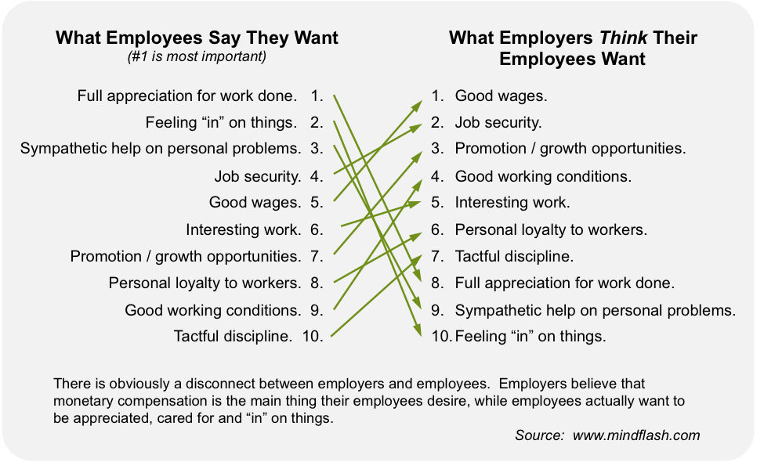

Job roles and responsibilities
A job description identifies essential and non-essential tasks that are assigned to a specific position. It also identifies reporting relationships and may also describe required qualifications, minimum requirements, working conditions, and desirable qualifications. Supervisors are responsible for developing and maintaining accurate and current job descriptions for their staff. The duties should be appropriate for the classification and consistent with the class specification. It is not uncommon for duty statements to vary within the same classification due to the various departmental settings and organisational structures. It is crucial that supervisors are able to explain job duties and responsibilities clearly so that new employees understand what they are supposed to do in their work role.

What are Task/Duty Statements?
Task/duty statements clearly and concisely describe work that is assigned and performed by an employee as part of their duties. A task statement typically begins with an action verb and identifies the object of the task. For example, what is the purpose of the action or to whom is it done? The statement should also identify the expected outcome/output of the product and identify any necessary tools required to complete the work.

Job role and responsibility examples
Look at the job descriptions below. Identify the main duties and responsibilities and discuss with your partner.

Tourism Officer
The role of a tourism officer is a combination of marketing, public relations and management. It also involves lots of planning and preparation.
Typical responsibilities of the job include:
- Supervising staff
- Preparing tourist or visitor information
- Producing promotional material and displays
- Managing budgets
- Writing reports, business plans and press releases
- Making presentations
- Maintaining statistical and financial records
- Undertaking day-to-day centre management and administration
- Liaising with local businesses and the media
- Market research.
Key skills for tourism officers:
- Interpersonal skills
- Communication skills
- Organisational skills
- IT skills
- Enthusiasm
- Adaptability
- Energy
- Resourcefulness
- Confidence.
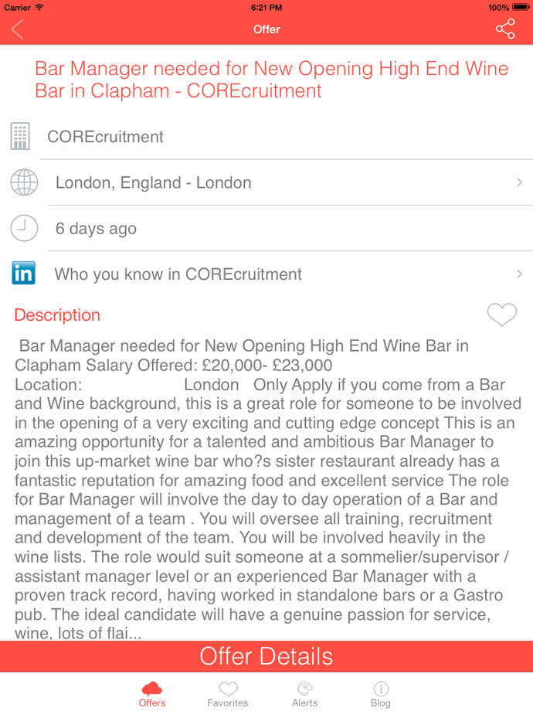
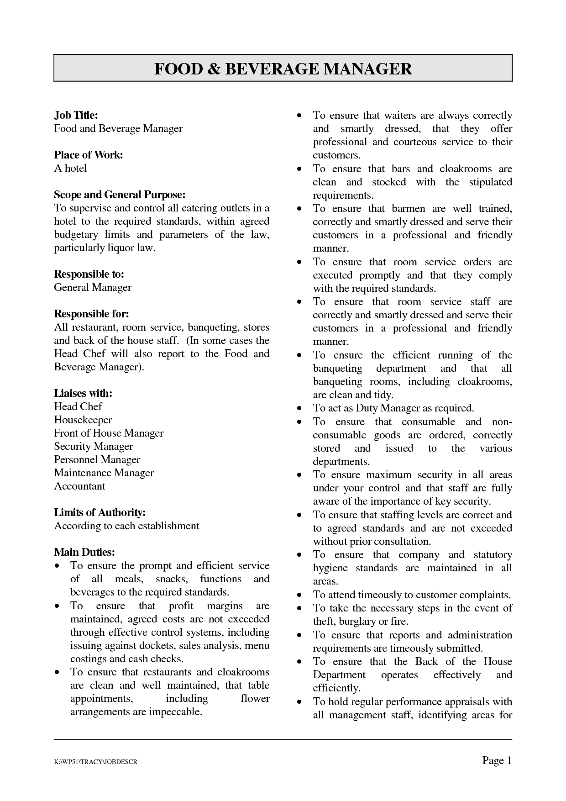

Language for describing job roles and responsibilities
Most job roles and responsibility descriptions will use verbs to direct actions required for the job. Below are some examples of common verbs that relate to job roles and responsibilities. They are often listed as dot points and roles, duties, tasks or responsibility statements might begin with:
- Job tasks include:
- Responsibilities include:
- Main duties are:

1.5 Show and explain features in the work area


Introduction
There are many different types of equipment and materials that may be required for particular jobs within an organisation. These materials and items will vary according to the role of the position. Chefs work areas are completely different from the work areas of reception staff or housekeeping and it is important to be able to describe and show staff their specific work areas and the features within their space.

Explaining work areas
In explaining a particular work area for a staff member
it may be useful to use phrases and expressions such as:
- There is/There are
- You will need....
- This is where you will be working.
- This is a/an......
- Have you used a................. before?


There are many individual items that may be used by different departments within the hospitality and tourism industry. Look at the items below and identify which position might use them. Choose from: Chef Housekeeper Pool Attendant Travel Agent Waiter 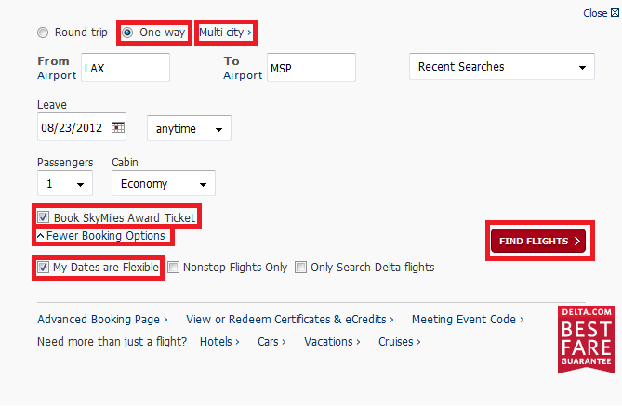  

Activity
Write down all of the main items, materials and equipment that are needed in your position or choose a job and list the relevant items. Describe the main items to your partner.

1.6 Outline details of any training requirements


Introduction
Training requirements for new employees could range from health and safety training to computer skills. The important aspect for any supervisor is the ability to explain and outline clearly what the training requirements are for the particular position. Before explaining the training requirements for a position or role, it is important to first identify the components of the training and the details in order to be able to describe the training needs effectively.

Training requirements
Certain positions within the hospitality and tourism sector will require specific skill sets for staff to be able to perform their roles effectively. Job and position descriptions will guide employees on the skills and experience required to be able to do the job but there may be company specific policies and procedures or tasks that need to be taught to all new employees to maintain operational consistency. Supervisors will have to be able to explain any specific training requirements that staff will need to undertake.
In describing training requirements, it may be useful to use expressions like:
- It is a requirement of the organisation that.......
- You will be required to.........
- You are expected to be able to............
- You will have to attend training for........
- Training will be provided for.........
- This position requires that you are trained in these areas:....
It will be important to be able to explain the main information relating to the training such as:
- When and how the training is delivered
- How long it takes
- What materials, items, clothing, or equipment is needed
- Who arranges the training and how they contact the employee to inform them of the training
- Where training takes place
- What happens if the training outcome is unsuccessful
- Is further training needed
- How often training must be updated
- Why the training is needed.

Types of training
Most staff will have to be trained in organisation specific duties and responsibilities. These could range from health and safety policies to answering a phone.
General training in organisations may include:
- Evacuation and emergency procedures
- First aid
- How to use equipment specific to a position
- HR manual/Operations manual use
- Annual/Sick leave procedures
- Customer service management
- Quality assurance
- IT
- Meeting request/attendance procedures.


Training plan example
Activity
Read through the training plan below and determine how you would describe this training to someone. Practice summarising the training with your partner.
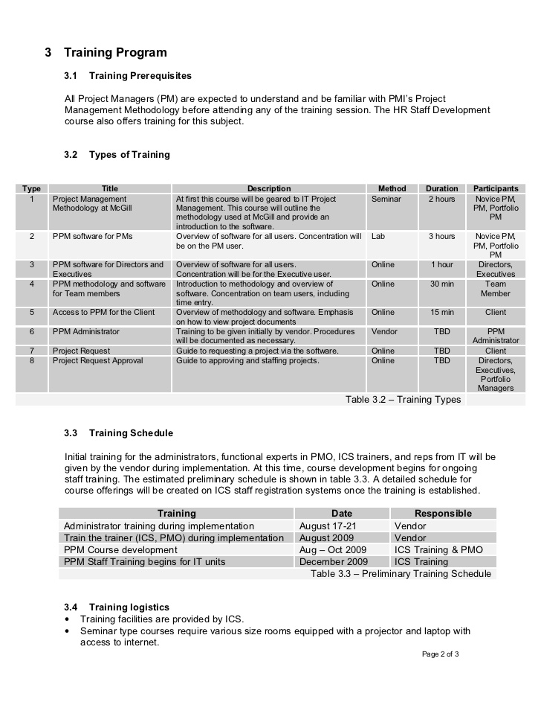
Work Projects
It is a requirement of this Unit you complete Work Projects as advised by your Trainer. You must submit documentation, suitable evidence or other relevant proof of completion of the project to your Trainer by the agreed date.
1.1 Explain to your trainer the new employee induction program at your organisation.
1.2. Bring an example of the organisational chart of your organisation to class and show your trainer.
1.3. Explain your company goals to your trainer:
- Provide the mission and vision statement of your organisation to your trainer.
1.4. Provide your trainer with three examples of job descriptions from your organisation.
1.5 Provide your trainer with a list of equipment and features of your work area.
1.6 Provide your trainer with a list of training that has been conducted at your organisation over the last six months:
- Bring the training plan or outline from one training session.

Summary

Use English to induct new employees
Inducting new employees into the organisation is a critical process in order to help them understand their job roles and responsibilities. There are many steps that are required to effectively prepare a new staff member for work and being able to use English to orientate staff members is an important skill to master. Templates and manuals can assist explaining job roles and responsibilities to staff members and can make access to English vocabulary simpler. When inducting new staff it is important to:
- Explain organisational goals and mission
- Introduce new staff members to key personnel
- How staff members their work areas and explain any features relevant to their job
- Explain job roles and responsibilities clearly
- Provide any necessary training or inform staff about any required training.

Element 2:
Conduct a staff meeting

2.1 Notify all relevant staff of scheduled staff meeting


Introduction
It will often be necessary to inform staff about regular meetings and the processes and procedures relevant to meetings. Each organisation will have different ways of organising and conducting meetings so it is important to be able to explain company specific meeting procedures clearly and effectively. Communicating with staff when a meeting will occur is a critical skill for all supervisors and there are many systems and options available to inform staff about meetings.

Communicating with staff
Often a challenging part of staff management is effective communication. When arranging a staff meeting it may be difficult to speak to all staff in person due to shift work, days off and annual leave. It is important, however, that all relevant staff are still able to attend a scheduled meeting or to be able to inform a supervisor of their inability to attend.
There are many ways to inform staff about meetings but nowadays using online calendars and meeting requests are common. Below is an example of a meeting request.
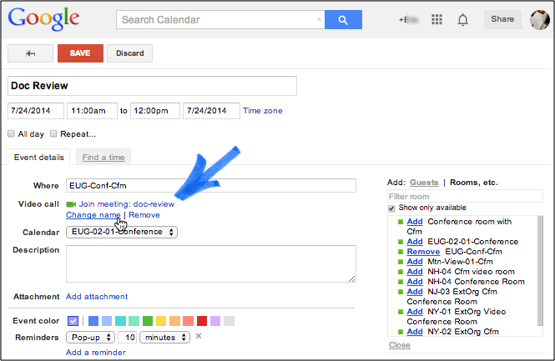

Ideas for email meeting invitations

Noticeboard
One common way to inform staff of a meeting is to use a staff noticeboard. The meeting information should include:
- Meeting title
- Date and time
- Location
- Reason for meeting
- Materials to bring or information to prepare
- Duration of meeting
- Attendees (people who need to attend).
Using a template can make scheduled meeting requests much easier and people become used to the format.

Online meeting requests
Below are some ideas for writing effective online meeting requests. There are eight suggestions, four required and four optional, these elements make for informative and professional meeting invitation email messages.
- Succinct Subject Line (required)
- Personal Introduction
- Required Preparation
- Meeting Date and Time (required)
- Location (required)
- Meeting Purpose (required)
- Agenda
- Invitee List

Succinct Subject line (Required!)
Just the facts, ma'am.
Follow best practices for any email by keeping your invitation subject line short and easy to scan. Include the meeting name, date, and an indication of what kind of invitation you're sending.
We use this pattern for the meeting invitation subject lines in Lucid Meetings.
Type of request + Meeting Date + Meeting Name

Example
Meeting invite for October 4th: Project Status Update
Of course, you don't always know when the meeting will happen, and scheduled meetings get moved. In those situations, we use variations on the basic pattern:
- Meeting request from Elise Keith: Project Kickoff
- Scheduled: Project Kickoff for September 23rd
- Rescheduled: Project Kickoff moved to September 24th
- Cancelled: Project Kickoff on September 24th.

WHY THIS FORMAT WORKS
People instantly know when you're requesting their time and the main topic of your meeting without even opening the email.


COMMON MISTAKE TO AVOID:
ABBREVIATIONS IN THE SUBJECT LINE
Many groups develop subject line abbreviations to aid a quick scan of meeting email, using subject lines such as:
[PM-MTG] check in
This can work great with a team that knows the abbreviation and who will get the meeting on their calendars automatically. When you invite someone outside your group, though, this shorthand falls apart. Believe it or not, not everyone uses Outlook or Google Calendar, so you need to actually include the meeting date in your subject line. And while your team knows that "PM" means "program manager" and "mtg" means "meeting", people from outside your group may not.
Recommendation: Use full words in your email subject line.

Personal Introduction (optional)
If you're meeting with a group that doesn't meet regularly, add a short personal note to the top of your invite to provide much needed context.
Something like "Hello everyone, looking forward to seeing you all at the big project Kickoff!" or "As we discussed on the phone last Tuesday, here's the invitation for our upcoming demo." These quick notes help busy people remember who you are and why they're receiving this invitation.

Required Preparation (optional)
Do people need to prepare reports, review a design, or gather facts to contribute to the meeting? Do you need people to RSVP so you can plan?
If you need people to come prepared, make sure you clearly provide these instructions right at the top of your message. Otherwise they will get missed.

Meeting Date and Time (Required!)
Make sure to include the full date and time of the meeting, including the time zone, in the text of your email. Spelling out month names helps avoid confusion for people from other countries who are used to seeing different date formats.
Example:
September 15, 3:00 - 3:45PM Los Angeles
If you're inviting people who live in other time zones, use TimeandDate.com to figure out the correct time and date for your invitees. When you use a calendar or meeting management software to send your invite, the recipients' calendars will also automatically translate the date and time in the attached calendar file to their preferred time zone.

Location: Physical or Online (Required!)
A meeting location may be either a physical place like a conference room, instructions for joining a virtual meeting, or both.
For virtual meetings, the location should include a link to join the online meeting, audio instructions or phone numbers, and any system requirements. For in-person meetings, the location should include enough detail that those invited can find the meeting on a map.
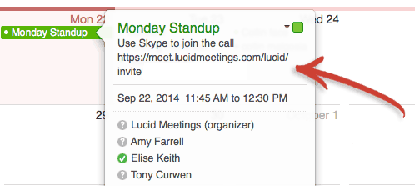
TIP: If you are sending invitations using a calendar program like Outlook, make sure to include the meeting phone number in the location field of the event. This makes it easy for people joining the meeting while traveling to dial in from a cell phone.

Meeting Purpose (Required!)
Why are you holding this meeting? What will it accomplish? Ideally, you can state the purpose of the meeting in a single sentence. The best purpose statements will describe the desired result for the meeting.
Examples:
- Get a demo and answer questions
- Share project status updates
- Create a list of issues with the invoicing process
- Develop a high-level strategy for the upcoming conference
- Compare offers from vendors and make a selection
- Review completed development and approve the work.

Agenda (optional)
Include the meeting agenda when you want participants to prepare in advance. The agenda needs to include the order in which you plan to discuss key topics and any instructions or material people should read before the meeting.
Invitations sent using meeting productivity software will take care of this automatically.


COMMON MISTAKE TO AVOID:
SENDING REPORTS AS ATTACHMENTS

i-Phone error message seen when trying to send email with large attachments.
Many meetings centre on reviewing documents; designs, reports, contracts, proposals, plans, estimates, research findings – all result in documents that get shared and discussed by those invited to your meeting.
Attaching these documents directly to the invitation email is simple and fast, but it creates problems:
- The email gets blocked.
This is the big one. Some mail servers are set up to block email that appears too large, has too many attachments, or that has attached files that the system determines may be harmful. When this happens, some people will never get your invitation

- The attachments can't be opened.
According to Litmus Lab's Email Market Share report, the number one email client is the iPhone. Some email clients will fail to open messages that appear too large, and some documents can't be opened on all systems. Ever try to open Excel attachments on an iPhone? Not fun
- The email gets lost.
You know this happens. Inboxes full of messages, so thank goodness you have the meeting invite on your calendar or you'd never make it. Many meetings lose precious time and attention as people hunt through old email to find the documents they've lost from their inbox
- Recommendation: Add a link to an online location where people can preview and/or download meeting documents. If you don't already have a solution for this, you can easily share links to files using free file sharing services such as Dropbox or Google Drive.

Invitee List (optional)

Need the social proof that this meeting will be worthwhile? Or that you have the backing authority to schedule it? Or that people will miss out if they don't go? Include the list of people invited to the meeting at the end of your invitation.


Things to consider
- Send detailed meeting invitations for scheduled business meetings. Invitations aren't necessary for ad-hoc meetings
- Failure to send a good invitation is inconsiderate and makes people unhappy!
- The amount of information you need to write from scratch depends on the software you use to send your email
- There are 4 required and 4 optional pieces of information to include.

2.2 Draw up an agenda for the staff meeting


Introduction
Creating an effective agenda is one of the most important elements for a productive meeting. The agenda communicates important information such as topics for discussion, the person who is presenting or discussion leaders and the how long the meeting will last. The agenda provides an outline for the meeting, is a checklist to ensure that all topics are covered, lets participants know what will be discussed and gives them a chance to come prepared for the meeting, and lastly provides a focus for the meeting.

Create an effective meeting agenda
Below are some ideas for creating an effective meeting agenda.
- Send an e-mail stating there will be a meeting, the goal of the meeting as well as the administrative details such as when and where it will be. Ask those invited to accept or decline the meeting. Make it clear that once they have accepted the meeting, they are expected to attend.
- Ask participants requesting an agenda item to contact you no less than two days before the meeting with their request and the amount of time they will need to present it.
- Once all of the agenda requests have been submitted to you summarize them in a table format with the headings Agenda Item, Presenter and Time. It's your responsibility to ensure that each agenda item is directly related to the goals of this particular meeting. If an inappropriate request is made, suggest that person send an e-mail or memo instead or recommend that this agenda item be discussed in another meeting. Also, you must be realistic in the amount of time you allocate to each presenter. Don't cram an unrealistic number of agenda items into an hour meeting. When people accept an hour meeting, they expect to be finished in an hour. When meetings go over time, people generally tend to get uneasy. It's better to schedule 50 minutes of discussion into an hour time slot. This way you have 10 minutes to spare and if you get done a little early, people will be pleased.
- Send the agenda to all the meeting participants the day before the meeting with a reminder of the meeting goals, location, time and duration. At this time, ask the presenters if they are happy with the order in which they will be speaking and the amount of time they have been allocated.
- Of course, the most important part of creating an effective agenda is to follow it during the meeting!

Activity
Look at the agenda template below. Complete the details with your own information.

2.3 Chair the meeting

Introduction

Being able to run a meeting effectively is an important skill to master. Directing a group of people towards an identifiable outcome is not always easy and being prepared is a key as well as being able to establish a respectful and professional environment where staff can both raise concerns and listen to others’ thoughts. Meetings are an important part of work and learning to conduct them appropriately can help to improve work performance.

The Role of the Chairperson
In a more formal meeting, the chairperson will outline the purpose of the meeting and remind members why they are there.
The chair controls the meeting:
- All remarks are addressed through the chair
- Members do not interrupt each other
- Members aim to reach a consensus
- A vote is taken if consensus is not reached
- The majority wins the vote
- All members accept the majority decision.
This is one model but alternative models may be adopted.
When discussion is underway, it is the chairperson's responsibility to ensure that it continues to flow smoothly by involving all members present and by not permitting one or two people to dominate the meeting. Summarising by the chairperson during meetings can:
- Indicate progress, or lack of
- Refocus discussion that has wandered off the point
- Conclude one point and lead into the next
- Highlight important points
- Assist the secretary if necessary
- Clarify any misunderstanding.
The chairperson should pace the meeting, ensuring it runs to time. If the planning has been properly executed, this should not prove to be a problem.
At the end of a meeting, the chairperson should remind members what they have achieved and thank them for their contributions. Finally, the time and date of the next meeting should be arranged. Again this is one common model for effective meetings, successful outcomes can be achieved in different ways with different strategies for different purposes, so adapt as appropriate to specific situations.

The Role of the Attendees
While it is the role of the chairperson to run the meeting, the participation of all attendees is also fundamental to the success of the meeting.
To ensure an effective meeting, all participants should:
- Undertake any necessary preparation prior to the meeting
- Arrive on time
- Keep an open mind
- Listen to the opinions of others
- Participate
- Avoid dominating the proceedings
- Avoid conflict situations
- Avoid side conversations which distract others
- Ask questions to clarify understanding
- Note down any action agreed upon
- After the meeting, undertake any agreed action and brief others as appropriate.

Why Meetings May be Ineffective
There are many reasons why meetings are not effective, some of these include:
- The meeting is unnecessary and revolves around discussion of trivial issues, thus wasting members’ valuable time
- The meeting lacks a clarity of purpose, i.e., the aims and objectives are not clearly defined
- Inappropriate style of leadership, i.e., the chairperson dominates and closes down or disregards other contributions
- The chairperson exercises little control and allows one or two members to dominate the proceedings
- The meeting is too large thereby limiting the flow of discussion and preventing all members being able to contribute
- Decisions emerge that are not truly representative
- Problems are talked about rather than being talked through
- Decisions are delayed or not acted upon
- No clear-cut decisions are made
- Minutes are inaccurate or seen as being manipulated by the chairperson or secretary for his/her own purposes
- The wrong people are present, thus preventing the meeting proceeding effectively, e.g., those present have to refer back to another person and are therefore unable to comment effectively.

2.4 Develop an action plan and dates


Introduction
During a meeting, discussion will often lead to a need to complete activities or actions. These actions will be agreed to by participants at the meeting and people will be allocated or will choose to undertake agreed actions. These actions will also need to be completed within a certain timeline. Developing an action plan can help to make sure that all activities are completed effectively.

Action plan development

Express your solution as a series of goals
Having agreed on a solution to a particular problem within your organisation, you first need to define that solution in terms of number of goals and objectives. For example, each goal could be expressed as follows: "For us to ....., we would need to ....." Record each goal at the top of a whiteboard or sheet of paper.

Generate a list of Actions for each goal
Use brainstorming to compile a list of actions to achieve a particular goal and record these below the goal. Arrange this list of suggested actions in sequential order.

Prepare a timeline
Beginning with a time point labelled "now" and ending with a point labelled "goal achieved", build a timeline on which you allocate dates by which you intend to complete each of the sequential actions listed under a particular goal. It is important that you get both sequence and timing right if you are to reach "goal achieved" effectively.

Allocate resources
Financial, physical and human resources must be allocated to each action step. If resources are limited, or fall short of requirements at any stage, it may be necessary to return to an earlier step and revise the action plan.

Identify possible problems
Consider all of the things that could go wrong in the process of achieving a particular goal. List these problems and identify causes and suitable actions to resolve them. If necessary, these actions might need to be added to appropriate slots in the timeline.

Develop strategies for monitoring progress
List ways in which progress of the action plan can be monitored. These monitoring stages should also be included on the timeline.

Assign tasks
Take each point on the timeline in turn and ask: "Who will do what, by the date set, to bring about the specified action? Allocate these tasks to appropriate individuals or teams.

Estimate costs/materials
Give consideration to any expenditure required to complete the task. All costs will have to be taken into account when preparing a budget. If funds are not available, tasks will have to be reviewed and, where necessary, revised or eliminated. It is also important to consider any materials that may be needed to complete the task.

Implement the plan
Translate all your information to a clean copy, listing the actions required, the person responsible for a particular task, and when that task is to be completed. Having now finalized the plan for action in specific terms, this information can now be made available to all involved.

Action plan template
Activity
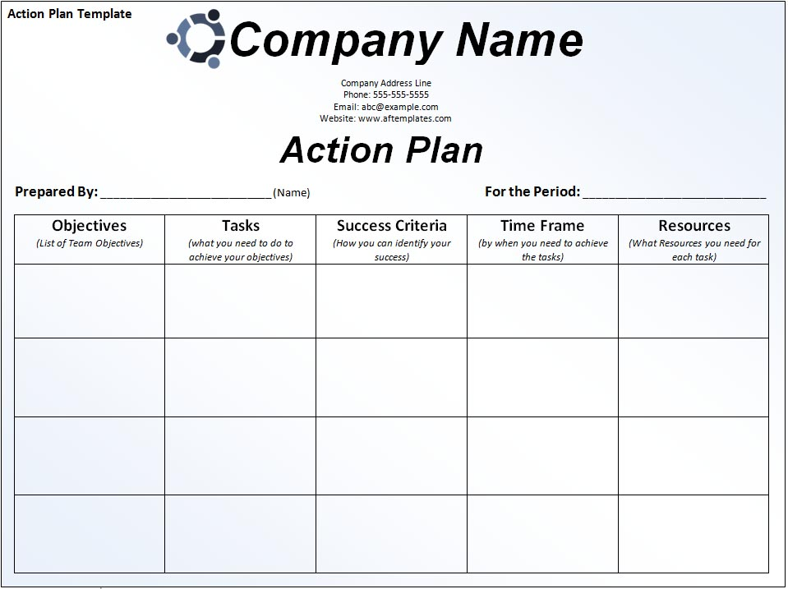
Look at the example of an action plan. Think of an objective from your work and complete the template with suitable information.

Work Projects
It is a requirement of this Unit you complete Work Projects as advised by your Trainer. You must submit documentation, suitable evidence or other relevant proof of completion of the project to your Trainer by the agreed date.
2.1 Provide a copy of a meeting request from your workplace.
2.2. Provide your trainer with a meeting agenda from your organisation.
2.3. Provide your trainer with meeting minutes from a meeting in your organisation.
2.4. Provide your trainer with an action plan resulting from a meeting within your organisation.

Summary

Conduct a staff meeting
Organising and attending meetings is a common work related activity and being able to arrange and chair a successful meeting in English can be challenging. There are many conventions that need to be followed to host effective meetings and as a supervisor it is an important aspect of work. Creating an effective agenda is one of the most important elements for a productive meeting and often a list of actions will need to be documented as well. An action plan lists the actions and how, who and when the tasks will be completed. It is important to make sure that everyone in a meeting understands the reason for the meeting and the outcomes agreed to.

Element 3:
Supervise and motivate a work team

3.1 Give clear instructions of work to be completed and realistic deadlines

Introduction

Giving clear understandable instructions is one of those things that sounds easy to do but in real life can actually be more complex, especially in an office environment or within a business. Mixed messages, assumptions and multiple options mean that the message received might differ from what was actually meant. It is important to be able to organise instructions into simple and understandable parts so that staff can complete the allocated tasks properly and in a timely manner.

Giving clear instructions

Don’t assume they know what you mean
It is important not to assume that people know what you mean. Whist most people in your office or business will be intuitive and switched on, they are not mind readers. An imperative when delivering clear instructions is to not assume the recipient knows what you mean, and this can be for anything from industry acronyms to who to contact in different departments or organisations. It will only take you a few seconds more to explain the details.

Be clear and specific
Whilst you don’t want to ramble on in your set of instructions, you do want to ensure that your instructions are clear, specific and concise. It is often better to get straight to be the point on what needs to be actioned or delivered, rather than making the instructions too flowery, which will only confuse.
For example, don’t just instruct “send a selection of the briefings to a few key stakeholders”, instead state how many stakeholders and to who, and what briefings! It often helps to bullet point as it reduces the temptation to waffle on and it helps your instructions and actions be more focused.

Give time frames
Do not confuse matters by not being specific with your time frames and deadlines. What you consider as “soon” might be very different from your colleagues. If you think “soon” is the next couple of hours, yet your staff who you have instructed considered it to be in a few days then this communication is going to have serious implications in any business or project!

Give examples
Whenever possible, make sure you give examples. This will be especially beneficial if staff are new to the role, or if they haven’t carried out the task before. This will help to add clarity to you instructions and help form a clearer picture of what it is you mean and want.
For example, if you are asking them to design a customer satisfaction survey for your new product then you might want to send them examples of other surveys previously used to give them bit of an idea.

Give alternatives
When delivering your instructions it is worth considering giving some alternatives just in case your preferred option of instruction is not viable or available.
For example, it could be “I want you to set up a meeting on the 20th of this month for 2 hours with the Finance Director. If they are not available on the 20th, then the afternoon of the 26th will be fine, or we can meet with the Chief Accountant instead”.
By giving alternatives you are empowering your staff to get the job done with minimal fuss and constant checking back in with yourself. The beauty of tasking someone else to do something is that you don’t have to do it, which will save you time. By setting alternatives they don’t have to keep coming back to you, after all it won’t save you time if you have to keep responding to queries.

Set boundaries
Once a task is set, the instructions should be clear enough that further confirmation and clarification is not needed (however saying this it is obviously best to seek clarification if unsure!) If this rings true with you then you need to make sure that your instructions are clear so that staff are certain what they are doing and don’t feel the need to keep coming back with questions. As with tip 5, setting boundaries is very important; especially if you cannot think of alternatives at the time then boundaries might work.
For example, you might instruct “go to the supplier and order 100 units. If the normal supplier is out of stock then it is fine to use a new supplier so long as they are no more than 10% more expensive and can deliver within 3 working days”. Here you haven’t been specific with your alternatives but clear enough on boundaries for them to make a decision.


3.2 Check instructions have been understood by all involved


Introduction
Before you let your staff loose on the basis of your instruction, it is useful to seek clarification from staff to ensure that they understand what the task at hand is and what is expected. You could simply ask at the end of a meeting if there are any questions but the one issue with that is that it is all too easy to just simply say “no”. Either they might think they understand or they might even be too shy to ask! It is more effective to check participants’ understanding.

Concept checking
Concept check questions are useful for meetings because they make sure that participants understand and are able to carry out the tasks that have been agreed to in a meeting. Concept checking is an effective way to determine if participants have grasped all of the necessary information.
Don't ask, "Do you understand?" because you will get a "Yes" response and have no real insight into the participant’s understanding.
To check the staff have grasped the concept, a question must be asked. Preparation of the question is very important. Use questions that involve thinking about the meaning and avoid asking questions that use the exact language from the presenter.
For example, some questions that could be asked to make sure staff have understood instructions are:

- How long have you got to complete these tasks?
- Who is responsible for task A, task B...?
- What do you need to complete the tasks?
- Who should you contact if you have a problem?
- Should you......?
- Will you.....?
- Gary, when is the next project update meeting? (Use names)
Make sure you ask everyone a question to check all participants understand, and if you sense that people don’t understand, go through the instructions again.

3.3 Give constructive feedback on performance

Introduction

Feedback is an essential element for everyone in an organisation's workforce. Giving feedback is a task you perform again and again as a manager or supervisor, letting people know where they are and where to go next in terms of expectations and goals – yours, their own, and the organisations. Feedback is a useful tool for indicating when things are going in the right direction or for redirecting problem performance. Your objective in giving feedback is to provide guidance by supplying information in a useful manner, either to support effective behaviour, or to guide someone back on track toward successful performance.

How to give useful feedback
Some situations which require giving constructive feedback include:
- Ongoing performance discussions
- Providing specific performance pointers
- Following up on coaching discussions
- Giving corrective guidance
- Letting someone know the consequences of their behaviour.
Some clues that constructive feedback is needed are when:
- Someone asks for your opinion about how they are doing
- Unresolved problems persist
- Errors occur again and again
- An employee's performance doesn't meet expectations
- A peer's work habits disturb you
- Someone’s work is exceptional or outstanding.

SIX WAYS TO MAKE FEEDBACK CONSTRUCTIVE
Part of being an effective manager or supervisor is knowing what feedback to give. The trick is learning how to give it constructively so that it has some value. Constructive feedback is a tool that is used to build things up, not break things down. It lets the other person know that you are on their side.
- If you can't think of a constructive purpose for giving feedback, don't give it at all.
- Focus on description rather than judgement. Describing behaviour is a way of reporting what has occurred, while judging behaviour is an evaluation of what has occurred in terms of "right or wrong", or "good or bad". By avoiding evaluative language, you reduce the need for the individual to respond defensively. For example: "You demonstrate a high degree of confidence when you answer customer questions about registration procedures, "rather than, "Your communication skills are good."
- Focus on observation rather than inference. Observations refer to what you can see or hear about an individual's behaviour, while inferences refer to the assumptions and interpretations you make from what you see or hear. Focus on what the person did and your reaction. For example: "When you gave that guest the evaluation form, you tossed it across the counter," rather than describe what you assume to be the person's motivation, "I suppose you give all forms out that way!"
- Focus on behaviour rather than the person. Refer to what an individual does rather than on what you imagine she or he is. To focus on behaviour, use adverbs, which describe action, rather than adjectives, which describe qualities. For example: "You talked considerably during the staff meeting, which prevented me from getting to some of the main points," rather than "You talk too much."
- Provide a balance of positive and negative feedback. If you consistently give only positive or negative feedback, people will distrust the feedback and it will become useless.
- Be aware of feedback overload. Select two or three important points you want to make and offer feedback about those points. If you overload an individual with feedback, she or he may become confused about what needs to be improved or changed. For example: "The number of applicants and the time it takes you to enter them are both within the expected ranges. The number of keying errors you are currently making is higher than expected."
Giving feedback constructively benefits everyone. You, as the manager or supervisor, use the ongoing exchange of information as a way of getting to know your people and providing them with valuable guidance in their work. The employee, manager, supervisor, or peer receives data that makes that makes her or his job go easier. The organization gains in improved productivity of its workforce.

THE SIX STEP METHOD FOR GIVING CONSTRUCTIVE FEEDBACK
Step 1: State the constructive purpose of your feedback
State your purpose briefly by indicating what you'd like to cover and why it's important. If you are initiating feedback, this focus keeps the other person from having to guess what you want to talk about. If the other person has requested feedback, a focusing statement will make sure that you direct your feedback toward what the person needs. For example:
- "I have a concern about."
- "I feel I need to let you know."
- "I want to discuss."
- "I have some thoughts about."
Step 2: Describe specifically what you have observed
Have a certain event or action in mind and be able to say when and where it happened, who was involved, and what the results were. Stick to what you personally observed and don't try to speak for others. Avoid talking vaguely about what the person "always" or "usually" does. For example:
"Yesterday afternoon, when you were speaking with Mrs Sanchez, I noticed that you kept raising your voice."
Step 3: Describe your reactions
Explain the consequences of the other person's behaviour and how you feel about it. Give examples of how you and others are affected. When you describe your reactions or the consequences of the observed behaviours, the other person can better appreciate the impact their actions are having on others and on the organization or team as a whole. For example:
"The staff member looked embarrassed and I felt uncomfortable about seeing the episode." "Shouting at our staff is not acceptable behaviour in this department."
Step 4: Give the other person an opportunity to respond
Remain silent and meet the other person’s eye, indicating that you are waiting for answer. If the person hesitates to respond, ask an open ended question. For example:
- "What do you think?"
- "What is your view of this situation?"
- "What are your reactions to this?"
- "Tell me, what are your thoughts?"

Step 5: Offer specific suggestions
Whenever possible make your suggestions helpful by including practical, feasible examples. Offering suggestions shows that you have thought past your evaluations and moved to how to improve the situation. Even if people are working up to expected standards, they often benefit from ideas that could help them to perform better.
If your feedback was offered supportively or neutrally, in the "for your information" mode, or depending on the situation's circumstances, suggestions may not be appropriate. Use your common sense and offer an idea if you think the other person will find it useful. Don't drum up a suggestion for improvement just for the sake of it.
For example:
"Jennifer, I sometimes write myself notes or put up signs to remind myself to do something."
"Jill, rather than telling Ed that you're not interested in all the details, you might try asking him specific questions about the information you are most interested in."
Step 6: Summarize and express your support
Review the major points you discussed. Summarize the Action items, not the negative points of the other person's behaviour. If you have given neutral feedback, emphasize the main points you have wanted to convey. For corrective feedback, stress the main things you've discussed that the person could do differently. End on a positive note by communicating confidence in the person's ability to improve the situation.
For example: "As I said, the way the group has figured out how to cover phone calls has really lessened the number of phone messages to be returned. You've really followed through on a tough problem. Please keep taking the initiate on problems like that.
By summarizing, you can avoid misunderstandings and check to make sure that your communication is clean. This summary is an opportunity to show your support for the other person — a way to conclude even a negative feedback situation on a positive note. For example: "At least we understand each other better since we've talked. I'll do what I can to make sure your priorities are factored into the schedule, and I'll expect you to come straight to me if the schedule is a problem.”

3.4 Seek suggestions for improvements from staff


Introduction
No matter how big or small your organization is, employees who don't feel like they have a voice can drain the oxygen out of other employees, lower productivity rates, and even cause increased turnover. Employees who feel voiceless are more likely to negatively impact on the day-to-day mood around the office. Giving workers of all levels a chance to express their thoughts on the direction of the company has the opposite effect: Show your employees you're interested in their opinions and they'll be more likely take a personal stake in the business. They'll go from feeling like they're working for the man to feeling like they're a part of the team.

How to engage employees and get feedback
Conducting a full-scale employee survey is still the most recommended method for gaining actionable employee feedback. Professionals recommend doing surveys on a regular basis, but say you shouldn't do it any more often than once a year because employees could lose interest if pressed for feedback too often.
Although it's recommended to tailor the specific questions to your company's current issues, though a common thread that most surveys seek to discover is how connected the employee feels to the company. Most surveys will inquire as to the whether the employee has a good work-life balance, whether they are proud to work for the organisation and how much effort they put into their work. Questions can also be tailored to find out how long the employee plans to stay with the company or what their feelings are about health and safety issues.
It is suggested that surveys be limited to between 35 and 55 questions and it shouldn’t take longer than 25 minutes to complete. Companies should allow time for employees to complete the survey whilst at work. It also helps to do the survey when the calendar is more likely to be clear: Avoiding the holidays or even your company's open enrolment period helps workers focus on their feedback.
Typically employee surveys get a 70 to 90 per cent response rate, but experts recommend several ways to ensure strong participation:
- Anonymity. If employees can be assured their responses won't lead to any retribution, they are much more likely to give honest answers, Deutsch says
- Proving access. Online surveys are considered the most efficient, but you'll need to make sure everyone in the company has access to a computer. This can be done by setting up a dedicated computer station in the human resources office or by scheduling time for certain workers to use a computer terminal
- Encouragement from management. A successful push for employee engagement has to be believable. That's why experts say if you really want to hear from your employees, you should have your top bosses encourage feedback on a regular basis or send out reminders
- Respond to the results. If staff feel they will be listened to and their ideas will be incorporated into work, then they will be much more engaged and likely to participate in surveys.
Work Projects
It is a requirement of this Unit you complete Work Projects as advised by your Trainer. You must submit documentation, suitable evidence or other relevant proof of completion of the project to your Trainer by the agreed date.
3.1 Use an action plan from a meeting, to show your trainer how work was delegated and monitored. Explain the instruction process to your trainer.
3.2. Explain to your trainer how you check that participants understand directives from a meeting.
3.3. Show your trainer an example of a performance review or a written form of feedback that has been provided to one of your staff.
3.4. Provide your trainer with an example of a staff survey or feedback form from your organisation.

Summary

Supervise and motivate a work team
Managing a team is an important role as a supervisor and maintaining the motivation and engagement of the team is critical to the success of the organisation. When managing a team, it is important to:
- Provide clear instructions to staff members
- Check that staff understand instructions
- Provide staff with feedback that helps them to improve their work
- Provide opportunities for staff to offer feedback and respond to suggestions effectively.

Presentation of written work

Introduction
It is important for students to present carefully prepared written work. Written presentation in industry must be professional in appearance and accurate in content. If students develop good writing skills whilst studying, they are able to easily transfer those skills to the workplace.

Style

Students should write in a style that is simple and concise. Short sentences and paragraphs are easier to read and understand. It helps to write a plan and at least one draft of the written work so that the final product will be well organised. The points presented will then follow a logical sequence and be relevant. Students should frequently refer to the question asked, to keep ‘on track’. Teachers recognise and are critical of work that does not answer the question, or is ‘padded’ with irrelevant material. In summary, remember to:
- Plan ahead
- Be clear and concise
- Answer the question
- Proofread the final draft.

Presenting Written Work
Types of written work
Students may be asked to write:
- Short and long reports
- Essays
- Records of interviews
- Questionnaires
- Business letters
- Resumes.
Format
All written work should be presented on A4 paper, single-sided with a left-hand margin. If work is word-processed, one-and-a-half or double spacing should be used. Handwritten work must be legible and should also be well spaced to allow for ease of reading. New paragraphs should not be indented but should be separated by a space. Pages must be numbered. If headings are also to be numbered, students should use a logical and sequential system of numbering.
Cover Sheet
All written work should be submitted with a cover sheet stapled to the front that contains:
- The student’s name and student number
- The name of the class/unit
- The due date of the work
- The title of the work
- The teacher’s name
- A signed declaration that the work does not involve plagiarism.
Keeping a Copy
Students must keep a copy of the written work in case it is lost. This rarely happens but it can be disastrous if a copy has not been kept.
Inclusive language
This means language that includes every section of the population. For instance, if a student were to write ‘A nurse is responsible for the patients in her care at all times’ it would be implying that all nurses are female and would be excluding male nurses.
Examples of appropriate language are shown on the right:
Mankind | Humankind
Barman/maid | Bar attendant
Host/hostess | Host
Waiter/waitress | Waiter or waiting staff

Recommended reading
Anthony, Robert N.; Dearden, John; & Vancil, Richard F. Management Control Systems. Homewood, Illinois: R. D. Irwin, 1972. 147-158
Bernard, Scott A. An Introduction to Enterprise Architecture. 2nd ed. Bloomington: AuthorHouse, 2005
Boynton, Andrew C. & Zmud, Robert W. “An Assessment of Critical Success Factors.” Sloan Management Review 25 (1984): 17-27
Bullen, Christine V. & Rockart, John F. “A Primer on Critical Success Factors.” Center for Information Systems Research, Sloan School of Management, Massachusetts Institute of Technology, 1981
Caralli, Richard A. The Critical Success Factor Method: Establishing a Foundation for Enterprise Security Management (CMU/SEI-2004-TR-010). Software Engineering Institute, Carnegie Mellon University, 2004. www.sei.cmu.edu/library/abstracts/reports/04tr010.cfm
Cassidy, Anita. A Practical Guide to Information Systems Strategic Planning. 2nd ed. Boca Raton, Florida: Auerbach Publications, 2006
Conway, M. “Scenario Planning: An Innovative Approach to Strategy Development.” Swinburne University of Technology, 2004
Daniel, D. Ronald. “Management Information Crisis,” Harvard Business Review, Sept.-Oct. (1961)
Fahey, Liam & Randall, Robert, eds. Learning from the Future. John Wiley & Sons, 1997
Fogg, Davis C. Team-Based Strategic Planning: A Complete Guide to Structuring, Facilitating, and Implementing the Process. New York: AMACOM/American Management Association, 1994. SOFTWARE ENGINEERING INSTITUTE | 48
Gregory, Erika; Harris, Gerald; & Ogilvy, Jay. “After the Scenarios, Then What? Strategic Conversation, Early Indicators, and the Art of Communication Scenarios.” Presearch. Provoking Strategic Conversation 2, 1 (1998)
Gunasekaran, Suresh & Garets, Dave. “Managing the IT Strategic Planning Process,” 22-34. Healthcare Information Management Systems Cases, Strategies, and Solutions. M. Ball, C.M. Weaver, and J. M. Kiel, ed. Springer, 2004
Hamel, Gary. “Strategy as Revolution.” Harvard Business Review (1996): 69-82
Mintzberg, Henry. “The Fall and Rise of Strategic Planning.” Harvard Business Review, January/February (1994): 107-114
Ogilvy, Jay & Schwartz, Peter. “Plotting Your Scenarios.” Global Business Network, 2004
Porter, Michael E. “What is Strategy?” Harvard Business Review, November-December (1996): 61-78
Raynor, Michael E. The Strategy Paradox: Why Committing to Success Leads to Failure (and What to Do About It). New York: Doubleday, 2007. SOFTWARE ENGINEERING INSTITUTE | 49
Rockart, John F. “Chief Executives Define Their Own Data Needs.” Harvard Business Review (1979): 81-92
Schoemaker, Paul J. H., Ch. 26, “Twenty Ward, John & Peppard, Joe. Strategic Planning for Information Systems. John Wiley & Sons. Ltd., 2002
Wilkinson, Lawrence. “How to Build Scenarios.” Wired (1995): 74-81

Trainee evaluation sheet

Use English at a supervisory level
The following statements are about the competency you have just completed.
Please tick the appropriate box | Agree | Don’t Know | Do Not Agree | Does Not Apply
There was too much in this competency to cover without rushing.
Most of the competency seemed relevant to me.
The competency was at the right level for me.
I got enough help from my trainer.
The amount of activities was sufficient.
The competency allowed me to use my own initiative.
My training was well-organised.
My trainer had time to answer my questions.
I understood how I was going to be assessed.
I was given enough time to practice.
My trainer feedback was useful.
Enough equipment was available and it worked well.
The activities were too hard for me.

The best things about this unit were:

The worst things about this unit were:

The things you should change in this unit are:

Trainee self-assessment checklist
As an indicator to your Trainer/Assessor of your readiness for assessment in this unit please complete the following and hand to your Trainer/Assessor.

Use English at a supervisory level
 |  | Yes | No*
Element 1: Use English to induct new employees
1.1 | Welcome new employee(s) and introduce them to key personnel
1.2 | Explain how the position relates to others in the company
1.3 | Speak positively about the company structure, goals and priorities
1.4 | Give information about the new employee’s roles and responsibilities
1.5 | Show and explain features in the work area
1.6 | Outline details of any training requirements
Element 2: Conduct a staff meeting
2.1 | Notify all relevant staff of scheduled staff meeting
2.2 | Draw up an agenda for the staff meeting
2.3 | Chair the meeting
2.4 | Develop an action plan and dates
Element 3: Supervise and motivate a work team
3.1 | Give clear instructions of work to be completed and realistic deadlines
3.2 | Check instructions have been understood by all involved
3.3 | Give constructive feedback on performance
3.4 | Seek suggestions for improvements from staff

Statement by Trainee:
I believe I am ready to be assessed on the following as indicated above:
Signed: _____________________________ | Date: ____________

Note:
For all boxes where a No* is ticked, please provide details of the extra steps or work you need to do to become ready for assessment.





